00a- Meeting Minutes - Supervisor

Part1: Meeting information

Group Number | 12
Project Phase: | Sprint 1
Date/Time: | May 4, 9:00am
Type: | Supervisor
Minute Taker: | Cole
Attendees: | Hoda, Cole, Kyle, Jonah, Nick, Abdullah
Regrets: | None

Part 2 Notes:

great introduction and problem statement
Good job at showing states and numbers
questionnaire is ready - very long - some of them does not speak English
required for questionnaire *
Job level? not task level?
do you need to redo the questionnaire? how much edit for the content is needed?
AI translations? Testing?
Existing database?
Sprint 1: UI and wireframe?

Part 3: Action Items
Owner | Task ID (existing or NEW) | Change / New Task Summary | Risk/Issue? (Y/N)  Risk ID | Status  (Open / Closed) | Screenshot of Trello Card(s)
Jonah | New - 30 | Created epic for language support | N | Open | 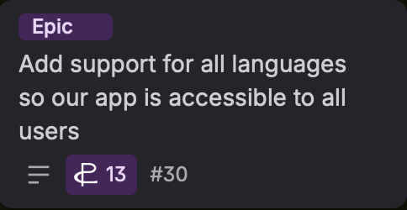
Jonah | New - 31 | Created epic for figma design implementation | N | Open | 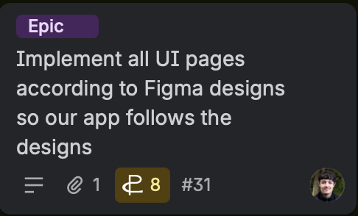
Jonah | New - 32 | Created epic for integrating AI to analyze user input and determine relevant tags. | N | Open | 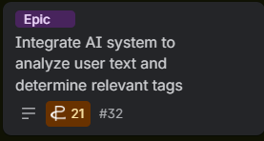
Jonah | New - 33 | Created epic for dynamically providing questions to users, depending on their answers to previous questions. | N | Open | 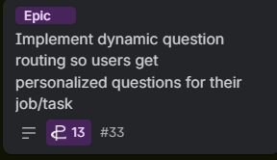
Jonah | New - 35 | Created an epic for implementing a report system after questionnaire completion. | N | Open | 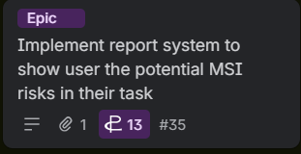
Jonah | New - 37 | Create epic for assigning risk scores to answers for all questions | N | Open | 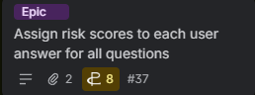
Jonah | New - 39 | Create epic for final presentation | N | Open | 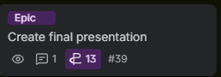
Jonah | New - 38 | Create epic for the test plan in sprint 3 | N | Open | 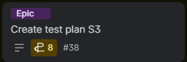
Jonah | New - 42 | Create epic for the test plan in sprint 1 | N | Open | 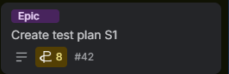
Jonah | New - 44 | Create epic for the test plan in sprint 2 | N | Open | 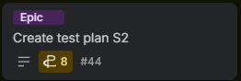
Jonah | New - 40 | Create epic to complete regression test | N | Open | 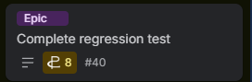

Part1: Meeting information

Group Number | 12
Project Phase: | Sprint 1
Date/Time: | May 6, 9:00am
Type: | Supervisor
Minute Taker: | Cole
Attendees: | Hoda, Cole, Kyle, Jonah, Nick, Abdullah
Regrets: | None

Part 2 Notes:

- We reviewed sprint progress and confirmed that most tasks are moving steadily through development, testing, and review stages
- Kyle is continuing work on the grading scale and formula mapping; after the client meeting, the provided Excel sheets still need investigation to determine whether they contain the correct scoring formulas
- Jonah and Nick completed question tagging and reduced the questionnaire from 36 to 25 questions for the developer workflow, while also exploring better pruning methods for trades-related use cases
- The team introduced clearer review and sprint tracking processes, including tagged reviewers, review deadlines, Discord notifications, and more measurable task breakdowns
- We agreed to improve client communication by creating detailed meeting minutes after each meeting, including action items and deadlines, with regular client meetings now scheduled for Tuesdays and Fridays

Part 3: Action Items
Owner | Task ID (existing or NEW) | Change / New Task Summary | Risk/Issue? (Y/N)  Risk ID | Status  (Open / Closed) | Screenshot of Trello Card(s)
Nick | #47 | Added review comment space for every member | N | Open | 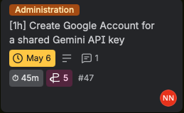

Part1: Meeting information

Group Number | 12
Project Phase: | Sprint 1
Date/Time: | May 8, 9:30am
Type: | Supervisor
Minute Taker: | Cole
Attendees: | Hoda, Cole, Kyle, Jonah, Nick, Abdullah
Regrets: | None

Part 2 Notes:

- We completed and tested scoring for the context, stress, force, and repetition categories, including validation of both low and high risk calculations and their corresponding result page messaging
- We identified a usability concern with the scoring system because the minimum score currently starts at 1 instead of 0, which could make users think there is always some level of risk present
- We plan to discuss the scoring scale with the client during today’s meeting, including whether a zero-based system or clearer disclaimers would improve user understanding
- Today’s client meeting will also focus on confirming sprint 1 completion, clarifying sprint 2 requirements, resolving question mapping gaps, and discussing multi-tagged questions
- Overall project management feedback was positive; the Trello board organization has improved significantly, though larger tasks should still be broken into smaller and more trackable pieces

Part 3: Action Items
Owner | Task ID (existing or NEW) | Change / New Task Summary | Risk/Issue? (Y/N)  Risk ID | Status  (Open / Closed) | Screenshot of Trello Card(s)

